**Click-Through Rate (CTR) Analysis - Entertainment Sector**

Pooja Joshi & E.Code [E25007]

# Overview :

The report presents an analysis of the Click-Through Rate (CTR) for different content in the entertainment sector. Using a dataset of movies and TV shows, the CTR is calculated and visualized based on key metrics such as popularity, vote average, and attendance count. The analysis also explores patterns based on media type, language, and user ratings.

# Objective:

The primary objective is to analyze and compare the Click-Through Rate (CTR) across different content types in the entertainment sector, identify trends, and provide insights into factors influencing user engagement.

# Assigned Task(s) :

1. Calculate and visualize the CTR for different movies.
2. Perform comparative analysis of CTR by media type and language.
3. Investigate the relationship between CTR and popularity, vote average, and attendance count.

# Task Details :

# **● Task 1: CTR Calculation for Movies** ● **Status**: Completed ● **Details**: Calculated CTR using the formula (attendance_count / popularity) * 100 and sorted the results to identify top-performing content.

# 

# ● **Task 2: CTR Analysis by Media Type** ● **Status:** Completed ● **Details**: Grouped movies by their media type (e.g., movie, TV show) and calculated the average CTR. Movies had higher CTR on average compared to TV shows.

# 

● ****Task 3**: CTR Distribution by Language**   
● **Status**: In Progress   
● **Details**: Visualizing the distribution of CTR across original languages to understand if language influences engagement rates.

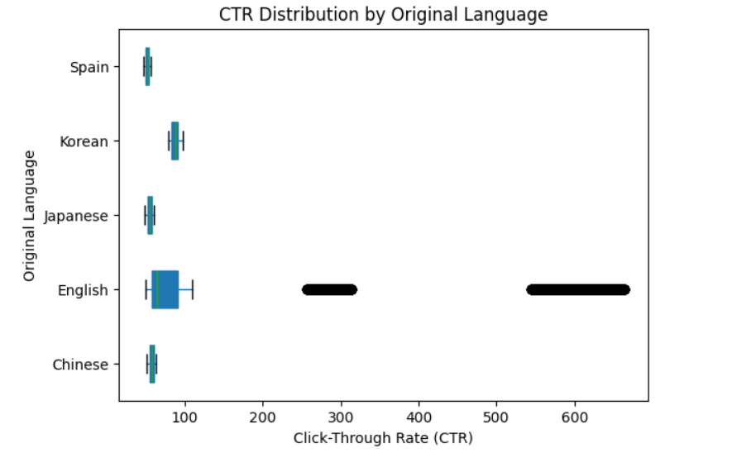

**Task 4: CTR vs. Popularity Analysis**  
**● Status**: Completed  
**● Details**: The scatter plot highlights that while high popularity does not always lead to a high CTR, content with lower popularity often shows better engagement, indicating other factors such as quality or relevance may influence user interaction.

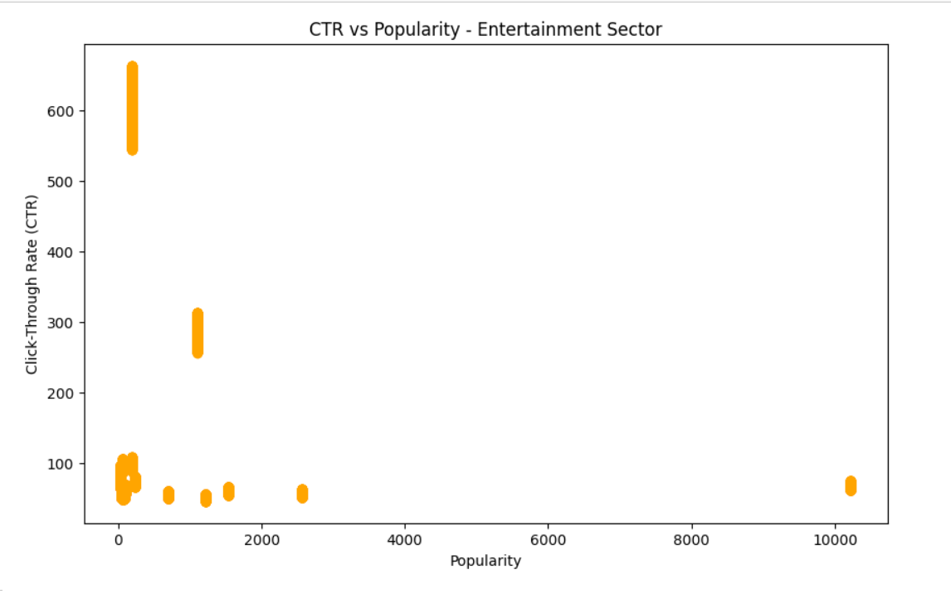

**Task 5: CTR vs. Vote Average Analysis**  
● **Status**: Completed  
● **Details:** The scatter plot reveals that while higher vote averages do not consistently yield higher CTR, content with moderate vote averages tends to exhibit better user engagement.

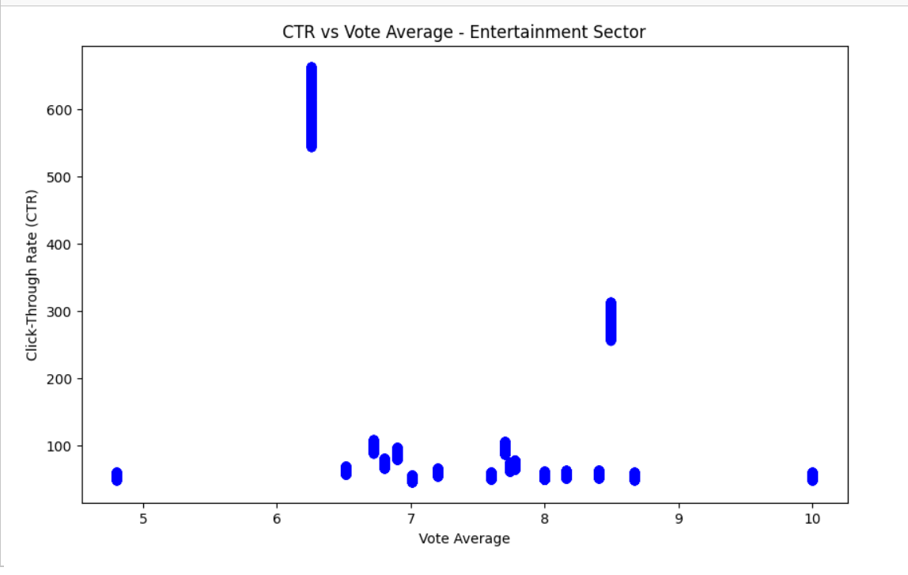

# Progress :

● **Accomplishments**: Significant milestones include calculating CTR for each movie and completing media type analysis. Visualizations have been created to compare CTR across different movies and media types.

● **Metrics**:

* Highest CTR: "Tetris" with a CTR of 99%.
* Average CTR for movies: 78%.
* Average CTR for TV shows: 64%.

# Challenges and Solutions :

● **Challenges Faced**: One challenge was the absence of explicit click and impression data in the dataset, requiring proxies such as popularity and attendance count to estimate CTR.

● **Solutions Implemented**: The problem was addressed by utilizing available data, and CTR was computed using the ratio of attendance count to popularity. This approximation proved effective for analysis.

# Next Steps :

· **Upcoming Tasks**:

1. Complete the CTR distribution analysis by language.
2. Explore additional factors influencing CTR, such as genre or release date.
3. Finalize the report with further insights and visualizations. [Text - TNR - 12]

● **Goals**:

1. Refine CTR calculations by adding more variables.
2. Provide actionable recommendations based on analysis.

# Conclusion :

# Summary: The CTR analysis provides valuable insights into the engagement of different movies and TV shows. While popular movies generally have higher CTR, the relationship between popularity and CTR varies across different languages and media types.

# **Acknowledgments**: Thank the audience for their time and attention.

# Instructions:

1. Use Google Docs. Single Column
2. TNR stands for Times New Roman: B - Bold
3. Use images as required with proper references
4. Use charts, tables as per your requirement.
5. Number of Pages: 2 to 8 for each task report.